NAME: SIVARANJANII.M
DATE:25.08.25 ROLLNO.:241901109

EXERCISE 4
DEVELOP A CUSTOMIZED PING COMMAND TO TEST THE SERVER CONNECTIVITY

AIM:
To develop a customized ping command using Python sockets that checks the connectivity of a server, measures the Round Trip Time(RTT) for multiple connection attempts, and computes the min, max, and average RTT values.
ALGORITHM:
- Set host, port, and number of pings.
- Create an empty list for RTT values.
- For each ping attempt:
- Start timer, connect to host, stop timer.
- Calculate RTT and store it, else print timeout.
- After all attempts, display min, max, and avg RTT.
CODE:
DEVELOP A CUSTOMIZED PING COMMAND TO TEST THE SERVER
import socket
import time
host = "google.com" # you can change this
port = 80 # HTTP port
count = 4 # number of pings
for i in range(count):
try:
s = socket.socket()
start = time.time()
s.connect((host, port))
end = time.time()
s.close()
print(f"Reply from {host}: time={(end-start)*1000:.2f} ms")
except Exception:
print("Request timed out")
CUSTOMIZED PING PROGRAM TO MEASURE MIN, MAX, AND AVERAGE RTT
import socket, time
host = "google.com"
port = 80
count = 4
times = []
for i in range(count):
try:
s = socket.socket()
start = time.time()
s.connect((host, port))
end = time.time()
s.close()
rtt = (end - start) * 1000
times.append(rtt)
print(f"Reply from {host}: time={rtt:.2f} ms")
except:
print("Request timed out")
if times:
print("\nMin RTT =", min(times), "ms")
print("Max RTT =", max(times), "ms")
print("Avg RTT =", sum(times)/len(times), "ms")

OUTPUT:
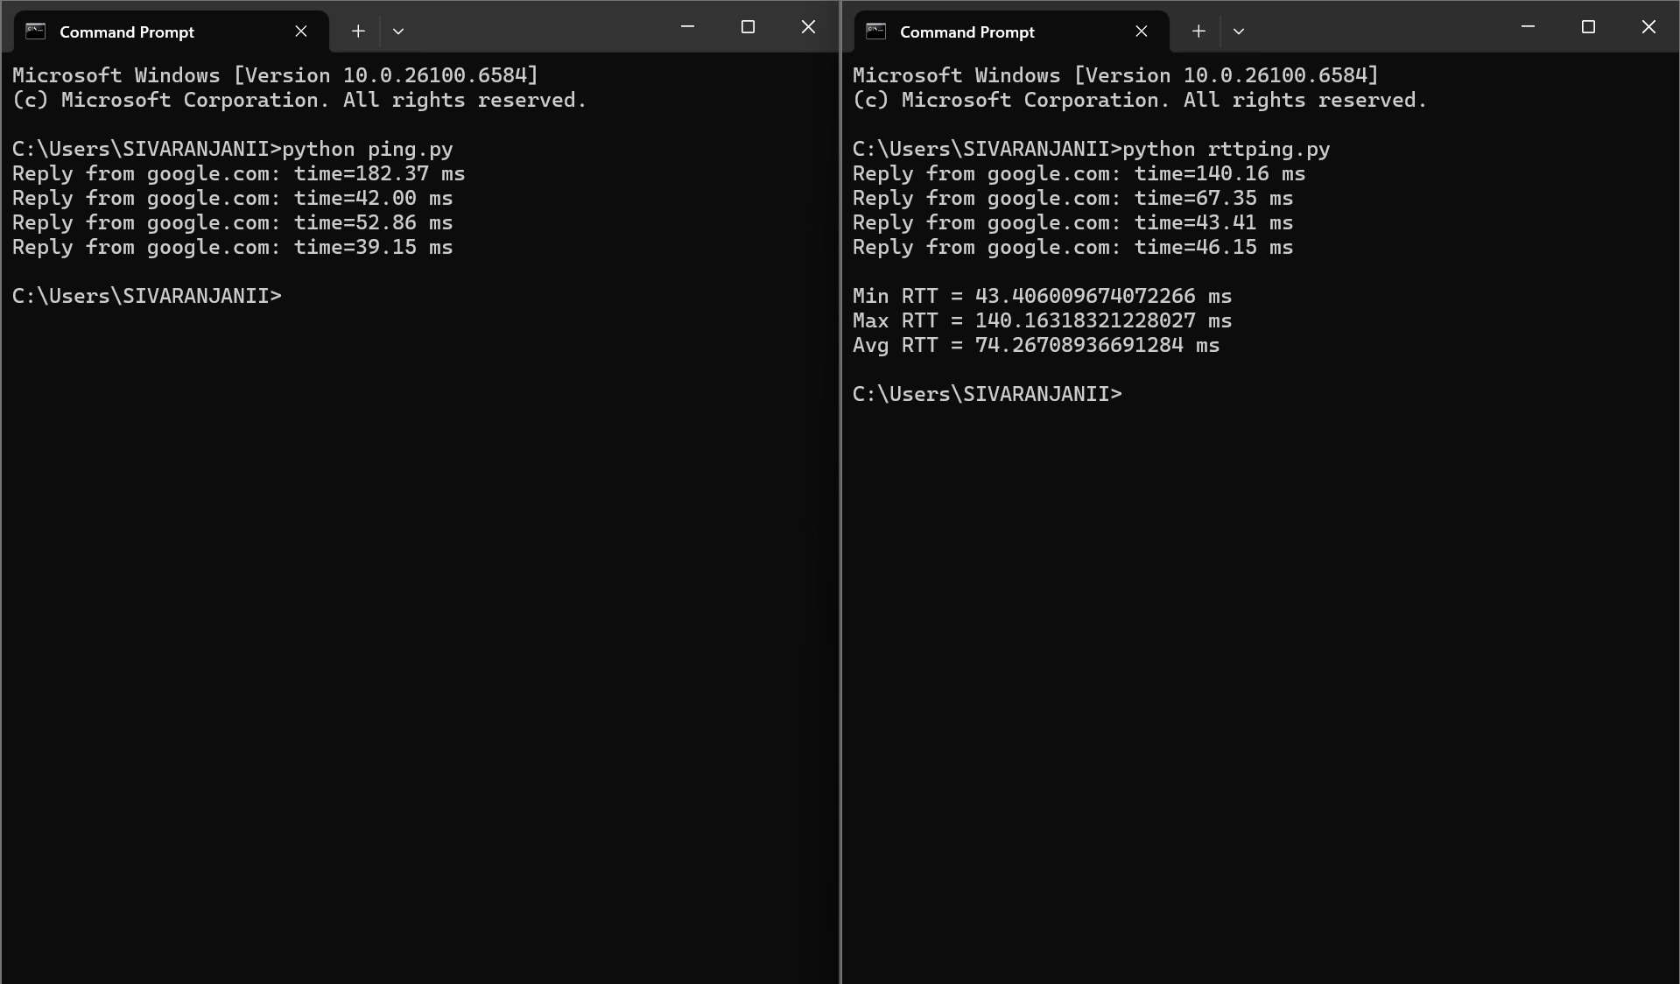

RESULT:
The program successfully checks server connectivity and displays min, max, and avg RTT values.

